Peer and Self Review

|  | P1 Sophia | P2 Haoxuan | Self |
| --- | --- | --- | --- |
| Project Quality | 1 | 1 | 1 |
| Input | 1 | 1 | 1 |
| Create, Read, | 1 | 1 | 1 |
| Update, delete | 0 | 0 | 0 |
| Individual code quality, review and observe comments | 1 | 1 | 1 |
| BE review, observe if Individual API handles error conditions | 0 | 0 | 1; no conformation page is shown if a blank submission is attempted |
| BE review, observe if Individual API contains GET and POST methods | 1 | 1 | 1 |
| BE review, observe that Individual code contains database operations that support Create, Read | 1 | 1 | 1 |
| BE review, observe that Individual code contains database operations that support Update, Delete (above requirement) | 0 | 0 | 0 |
| **Total** | **6** | **6** | **7** |
| Below are silent review scores |  |  |  |
| [Team RT](https://github.com/shruthim0/datapirates/issues/6) |  |  | 1 |
| [Individual RT](https://github.com/jiya-sav/jiya_repository/issues/18) |  |  | 0.5 |
| Runtime Links (on RT issue) |  |  | 0.5 |
| [Guides for Review](https://docs.google.com/document/d/1T-gslYWxmmmAJwZMclSZqbMe605QItrsWZ_DfguLihw/edit?usp=sharing) |  |  | 0.5 |
| Technical Achievements, backend focus (below) |  |  | 0.5 |
| Video (on RT issue) |  |  | 0.5 |
| GitHub analytics (on RT issue) |  |  | 0.5 |
| Bonus, substitute and personal achievement for .5 more |  |  | 0 |
| **Total** |  |  | **4** |

**Overall total + NATM blog: 10.33 avg**

Personal Achievements

Debugging and finding/ fixing errors on aws: While connecting frontend to backend, I had many issues with fetching the aws link. I learned that before committing a change on our flask server, my teammates and I should run the command docker-compose up --build, so we can find and fix errors before crashing our entire deployed site. I also made use of the inspect feature on my browser when finding issues with my frontend, specifically formatting and when the table of recipes was not displaying correctly. I found that adding alerts throughout each step was a great way to see where errors occurred, so I could pinpoint the exact problem within my code.

Evidence of Requirements

Link to video demonstration of project: <https://www.loom.com/share/ff02b8538267459f9a4dfc420c69c04a>

**Input:**

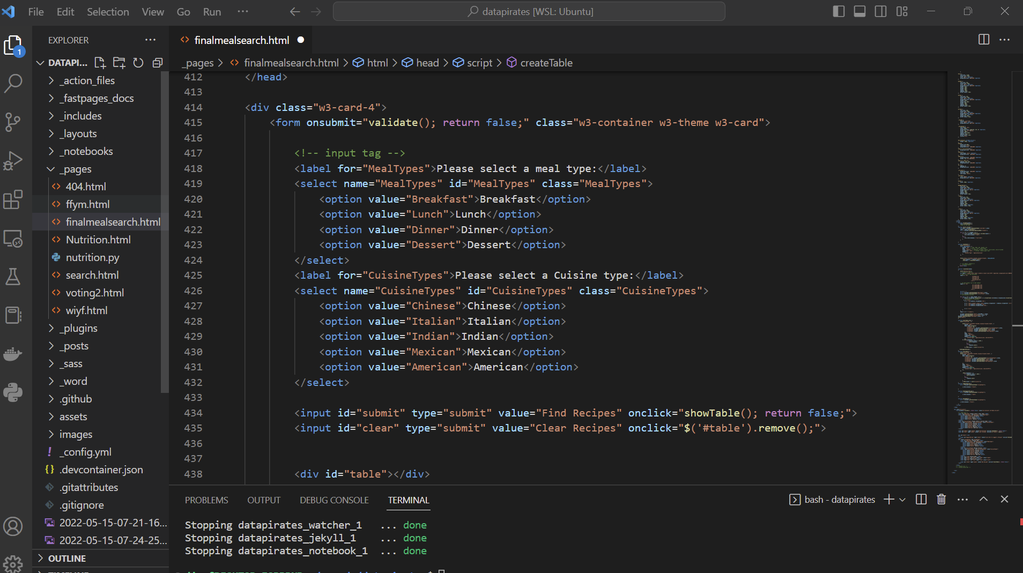

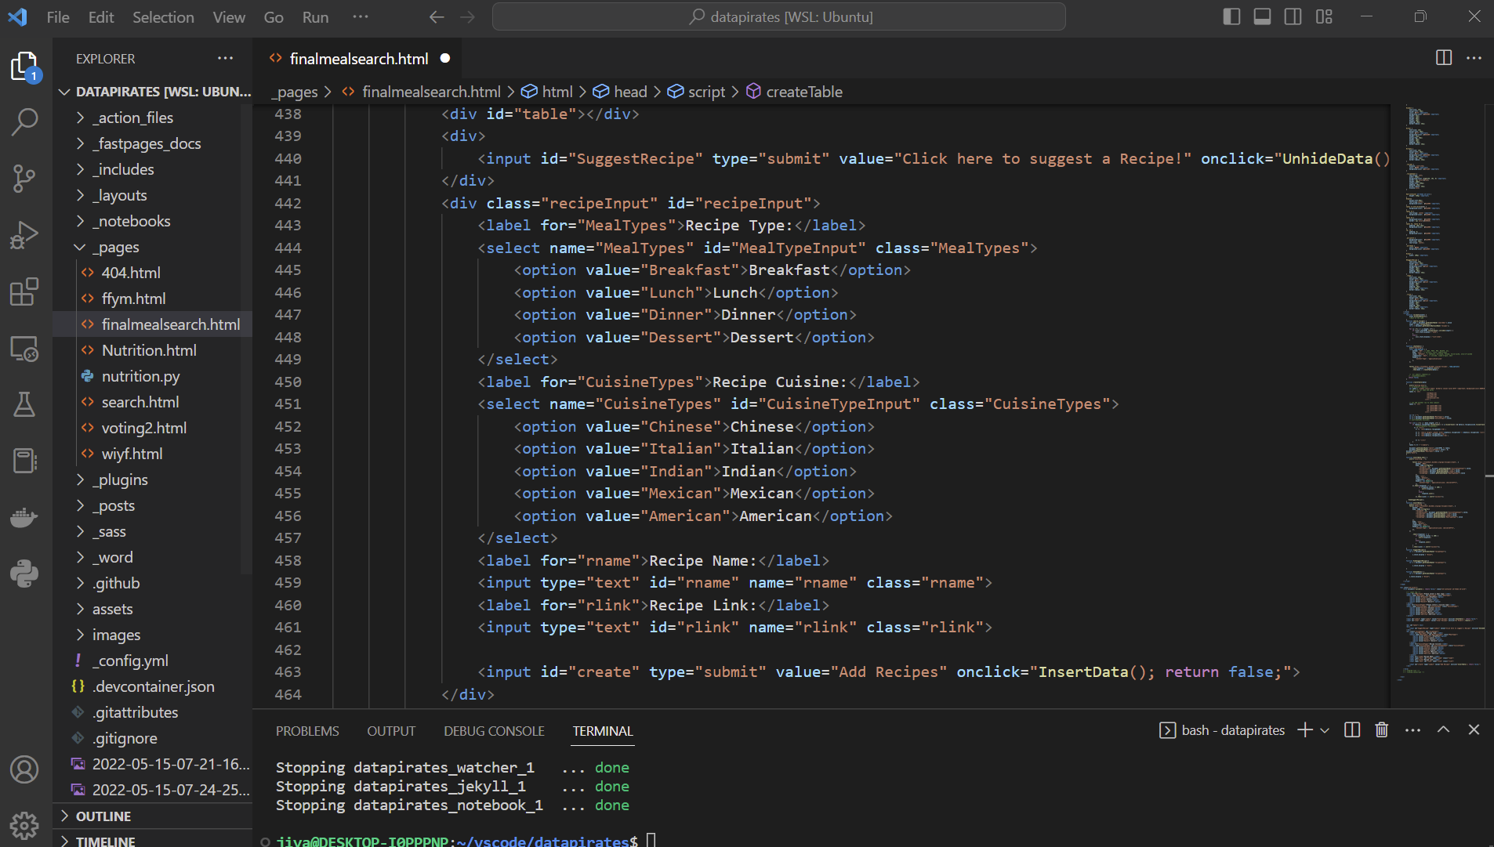

**Create + Read (see video for demonstration)**

**Error Correction + Testing (many alerts)**

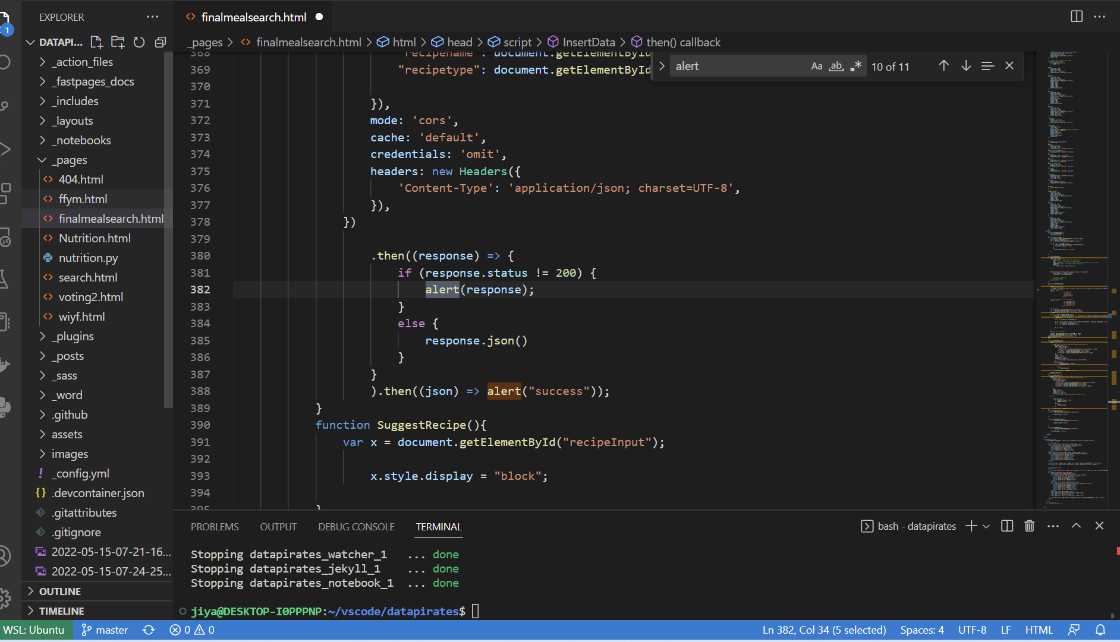

**Operations in Fastpages code that support Create + Read**

